South Australia
Cooper Basin (Ratification) Act 1975
An Act to ratify and approve a certain Indenture between the State of South Australia and others; and for other purposes.

Contents
1 Short title
3 Interpretation
4 Position of Commonwealth Government
5 Amending agreements to be approved by Act
6 Ratification of Indenture
7 Power in Governor to vest lands
8 Modification of application of law of State to certain real property
9 Grant of licences under Petroleum Act
10 Contiguous areas etc
11 Additional powers of Minister
12 Additional rights to licensees
13 Rates, taxes etc
14 Exemptions
15 Remote supervisory control systems
16 Approval of certain things
17 No liability to partition
18 Royalties
19 Non-application of section 24A of Arbitration Act
20 Application of this Act to lands subject to Real Property Act
21 Other Acts or law not affected
22 Regulations
Schedule—The Indenture
Legislative history

The Parliament of South Australia enacts as follows:
1—Short title
This Act may be cited as the Cooper Basin (Ratification) Act 1975.
3—Interpretation
(1) In this Act, unless the contrary intention appears—
AGL Letter of Agreement means the letter of agreement entered into on 26 May 1971 between The Australian Gas Light Company of the one part and Alliance Petroleum Australia NL, Basin Oil NL, Bridge Oil Ltd (formerly Bridge Oil NL), Delhi International Oil Corporation, Pursuit Oil NL, Reef Oil NL, Santos Ltd, Total Exploration Australia Pty Ltd, and Vamgas NL of the other part and includes all agreements supplementing or amending that agreement—
(a) that were made before the commencement of the Cooper Basin (Ratification) Amendment Act 2003; or
(b) that are authorised or ratified by an Act; or
(c) that are submitted to, and approved by, the Minister as being of only minor significance;
authorised agreement—each of the following is an authorised agreement:
(a) the Indenture;
(b) the Liquids Agreement;
(c) the AGL Letter of Agreement;
(d) the Fixed Factor Settlement Agreement;
(e) the Right of Way Agreement;
(f) the Unit Agreement;
(g) the Downstream Agreement;
(h) Pipeline Licence No 2;
(i) each of the Liquids Sales Contracts;
Downstream Agreement means the agreement made on 31 December 1981 between Alliance Petroleum Australia NL, Basin Oil NL, Bridge Oil Ltd, Bridge Oil Developments Pty Ltd, Crusader Resources NL, Delhi Petroleum Pty Ltd, Reef Oil NL, Santos Ltd, South Australian Oil and Gas Corporation Pty Ltd, Total Exploration Australia Pty Ltd, and Vamgas Ltd and includes all agreements supplementing or amending that agreement—
(a) that were made before the commencement of the Cooper Basin (Ratification) Amendment Act 2003; or
(b) that are authorised or ratified by an Act; or
(c) that are submitted to, and approved by, the Minister as being of only minor significance;
Fixed Factor Settlement Agreement means the agreement dated 5 December 1996 between Santos Ltd, Delhi Petroleum Pty Ltd, Santos Petroleum Pty Ltd, Boral Energy Resources Ltd, Vamgas Pty Ltd, Crusader Resources NL, Bridge Oil Developments Pty Ltd, Santos (BOL) Pty Ltd, Reef Oil Pty Ltd, Alliance Petroleum Australia Pty Ltd, and Basin Oil NL and includes all instruments supplementing or amending that agreement—
(a) that were made before the commencement of the Cooper Basin (Ratification) Amendment Act 2003; or
(b) that are authorised or ratified by an Act; or
(c) that are submitted to, and approved by, the Minister as being of only minor significance;
Indenture means the indenture a copy of which is set out in the Schedule and includes appendices forming part of that indenture and, subject to section 5, includes that indenture as amended;
liquids means any product (as defined in the Liquids Agreement) to which the Liquids Agreement relates;
Liquids Agreement means the Stony Point (Liquids Project) Indenture;
Liquids Sales Contracts means the contracts for or in relation to the sale of liquids made by the Producers or any one or more of them before the commencement of the Cooper Basin (Ratification) Amendment Act 2003 and includes all instruments supplementing or amending any such contract—
(a) that were made before the commencement of the Cooper Basin (Ratification) Amendment Act 2003; or
(b) that are authorised or ratified by an Act; or
(c) that are submitted to, and approved by, the Minister as being of only minor significance;
party includes an agent, successor or assign of a party;
Pipeline Licence No 2 means the pipeline licence referred to in the Liquids Agreement as Pipeline Licence No 2;
Right of Way Agreement means the agreement referred to in the Liquids Agreement as the PASA and Producers (Right of Way) Agreement and includes all instruments supplementing or amending that agreement—
(a) that were made before the commencement of the Cooper Basin (Ratification) Amendment Act 2003; or
(b) that are authorised or ratified by an Act; or
(c) that are submitted to, and approved by, the Minister as being of only minor significance;
Unit Agreement means the agreement entered into on 21 December 1976 between Alliance Petroleum Australia NL, Basin Oil NL, Bridge Oil Ltd, Delhi International Oil Corporation, Pursuit Oil NL, Reef Oil NL, Santos Ltd and Vamgas NL and includes all agreements supplementing or amending that agreement (including supplementary or amending agreements to which a person who is not a party to the principal agreement is a party)—
(a) that were made before the commencement of the Cooper Basin (Ratification) Amendment Act 2003; or
(b) that are authorised or ratified by an Act; or
(c) that are submitted to, and approved by, the Minister as being of only minor significance.
(2) Where an expression used in this Act is defined in Clause 1 of the Indenture that expression shall, for the purposes of this Act and unless the contrary intention appears, bear the meaning assigned to it by that clause.
4—Position of Commonwealth Government
(1) It is the intention of the Parliament that this Act, so far as it lawfully may, shall be held and construed as applying to the Commonwealth and any agency, instrumentality or authority of the Commonwealth in so far as the Commonwealth or any such agency, instrumentality or authority is or becomes a party to the Indenture.
(2) The Petroleum Act 1940 shall apply and have effect to and in relation to the Indenture and to any matter or thing arising thereunder as if there were inserted in subsection (1) of section 6 of that Act after paragraph (iii) of that subsection the following passage:
or
(iv) the Commonwealth, or any agency, instrumentality or authority of the Commonwealth.
(3) The Petroleum Act 1940 shall apply and have effect to and in relation to the Indenture and in any matter or thing arising thereunder as if there were inserted in section 41 of that Act after paragraph (c) the following passage:
and
(d) if made by the Commonwealth, any agency, instrumentality or authority of the Commonwealth—be signed by such person as the Minister requires.
(4) The Petroleum Act 1940 shall apply and have effect to and in relation to the Indenture and any matter or thing arising thereunder as if the expression "person" therein extended to include a reference to the Commonwealth and any agency, instrumentality or authority of the Commonwealth.
5—Amending agreements to be approved by Act
(1) No agreement, made on or after the commencement of this Act, purporting to amend the Indenture shall, for the purposes of this Act, have any force or effect until it has been ratified by an Act.
(2) Any Act that ratifies an agreement referred to in subsection (1) of this section may provide that the agreement shall be deemed to have been ratified on a day that occurred before the day on which that Act was enacted.
6—Ratification of Indenture
(1) The Indenture is hereby approved and ratified.
(2) The Premier, the Minister and the Government of the State are hereby authorised, empowered and required to do all things necessary or expedient for the carrying out of and the giving of full effect to the Indenture.
7—Power in Governor to vest lands
For the purposes of giving effect to subclause (1) of clause 4 of the Indenture and, notwithstanding any Act or law to the contrary the Governor may grant—
(a) an estate in fee simple over the land referred to in that subclause as being delineated in red on the plans annexed to the Indenture as Appendix "A" thereof; and
(b) the easements and rights referred to in that subclause.
8—Modification of application of law of State to certain real property
To the extent and only to the extent necessary to give effect to the expressed intent of subclause (2) of clause 4 of the Indenture and notwithstanding any Act or law to the contrary every Act or law of the State shall apply and have effect as if the buildings, structures, improvements, plant, equipment and other property referred to in that subclause were chattels.
9—Grant of licences under Petroleum Act
(1) Notwithstanding anything in the Petroleum Act 1940 and in lieu of or substitution for any other petroleum production licence under that Act, the Minister is, by this section, authorised to—
(a) grant to the Producers referred to in subclause (1) of clause 6 of the Indenture a licence under that Act of the kind and in the form of or to the effect set out in Appendix "B" to the Indenture or in such other form as may be agreed between the Minister and the Producers in order to implement or otherwise give effect, from time to time, to the provisions of the Unit Agreement; and
(b) approve the grant of sub-licences in the form of or to the effect set out in Appendix "B" to the Indenture or in such other form as may be agreed between the Minister and the Producers in order to implement or otherwise give effect, from time to time, to the provisions of the Unit Agreement,
and that Act shall, subject to this Act, apply and have effect accordingly.
(2) However—
(a) an application for a petroleum production licence made between 30 October 1997 and 27 February 1999 was required to meet the criteria established by sections 27 and 28 of the Petroleum Act 1940; and
(b) no further licence or approval has been, or will be, granted under this section in respect of an application made after 27 February 1999 (but this paragraph does not affect the renewal of a licence or approval granted in respect of an application made before that date).
10—Contiguous areas etc
(1) Section 36(1a) of the Petroleum Act 1940 applies and has effect to and in relation to the areas the subject of any licence under that Act the grant of which is authorised under this Act, as if those areas were contiguous areas.
(2) Subsection (3) of section 36 of the Petroleum Act 1940 shall apply and have effect to or in relation to the areas the subject of any licence under that Act, the grant of which is authorised by this Act, as if those areas were an area comprised in a licence.
11—Additional powers of Minister
In the application of the Petroleum Act 1940 to or in relation to any licence granted under that Act, the grant of which is authorised by this Act, paragraphs (a) and (b) of subclause (6) of clause 6 of the Indenture shall apply and have effect as if they were, mutatis mutandis, enacted in that Act.
12—Additional rights to licensees
(1) In addition to and not in derogation from the relevant right conferred on the licensees of licences under the Petroleum Act 1940, the grant of which are authorised by this Act, those licences shall confer on the licensees a right to construct and maintain all facilities being pipelines, pumping stations, tanks and roads as are necessary for the operations to be conducted under the Unit Agreement with respect to any area within the Subject Area not then comprised in any such licence.
(2) In this section—
the relevant right means the right conferred under section 33 of the Petroleum Act 1940.
13—Rates, taxes etc
Notwithstanding any Act or law to the contrary—
(a) the imposition or levying of any rate, tax, impost or other charge in contravention of subclause (1) of clause 7 of the Indenture; or
(b) the imposition of any rate, tax, levy, impost or other charge in contravention of subclause (2) of clause 7 of the Indenture,
shall be void and of no effect.
14—Exemptions
The instruments agreed pursuant to clause 9 of the Indenture to be exempt from stamp duties under the laws of the State are and shall be deemed always to have been by force of this section exempt from all duties otherwise chargeable pursuant to the Stamp Duties Act 1923.
15—Remote supervisory control systems
The provisions of the Petroleum Act 1940 shall apply and have effect to and in relation to the operation by the Producers of wells, field facilities, gathering systems and trunklines by remote supervisory control systems to the exclusion of section 34 of the Boilers and Pressure Vessels Act 1968 and any other Act or law which would otherwise prevent such operation.
16—Approval of certain things
The following things are specifically authorised for the purposes of section 51 of the Trade Practices Act 1974 of the Commonwealth:
(a) the authorised agreements; and
(b) anything done (before or after the commencement of this section) by a party, or anyone acting on behalf of a party, under or to give effect to the authorised agreements or any of them; and
(c) anything done (before or after the commencement of this section) to give effect to the conditions of Pipeline Licence No 2; and
(d) all contracts, arrangements, understandings, practices, acts and things done or made by the Producers or any of them before the commencement of this section and related to the sale or delivery of liquids;
(e) a contract, arrangement, understanding, practice, act or thing done or made by the Producers or any of them after the commencement of this section and related to the sale or delivery of liquids if—
(i) the Producers have given written notice of it to the Minister; and
(ii) the Minister has not, within 60 days after receiving that notice, given notice to the Producers excluding it from the ambit of this section on the ground that it is contrary to the public interest.
17—No liability to partition
Notwithstanding any Act or law, every relevant Act or law of the State that is applicable to the partition of real or personal property shall, to the extent necessary to give effect to the expressed intent of clause 11 of the Indenture, apply and have effect accordingly.
18—Royalties
Notwithstanding anything in the Petroleum Act 1940, royalties to which clause 12 of the Indenture applies shall be determined, calculated and payable in the manner set out in clause 12 of the Indenture and payment of royalties so determined, calculated and payable shall be a discharge from liability for payment of royalties under that Act.
19—Non-application of section 24A of Arbitration Act
Section 24A of the Arbitration Act 1891 shall not apply to or in relation to any submission or agreement to submit to arbitration under or arising out of—
(a) the Indenture; and
(b) the Unit Agreement and any other agreement relating to the rights and obligations of the Producers as between themselves under the Unit Agreement; and
(c) the Sales Contracts; and
(d) the Exploration Indenture; and
(e) the P.A.S.A. Future Requirements Agreement and any contracts entered into pursuant to the P.A.S.A. Future Requirements Agreement.
20—Application of this Act to lands subject to Real Property Act
Notwithstanding the provisions of the Real Property Act 1886, as amended, this Act shall apply to land that is subject to the provisions of that Act.
21—Other Acts or law not affected
Except as is expressly or by necessary implication provided by this Act, nothing in this Act affects the operation of any other Act or law.
22—Regulations
(1) The Governor may make such regulations as are necessary or expedient for the purpose of giving effect to the provisions or objects of this Act or the Indenture.
(2) Without limiting the generality of subsection (1) of this section the Governor may by regulation dispense with, suspend or vary, so far as is necessary, for the purpose of carrying out or giving effect to the Indenture any provision of any Act, by-law, rule or regulation or other provision having the force of law (under whatever authority made) and which in the opinion of the Governor having regard to the representations, if any, of the Producers prevents or impedes or would prevent or impede the carrying out or giving effect to the Indenture and any such regulation shall apply and have effect as if it were enacted in this Act.

Schedule—The Indenture
THIS INDENTURE made the 16th day of October, 1975 BETWEEN: THE STATE OF SOUTH AUSTRALIA (hereinafter referred to as "the State") of the first part THE MINISTER OF MINES AND ENERGY the Minister administering the Petroleum Act, 1940-1971 and the Mining Act, 1971-1973, a corporation sole pursuant to the provisions of the said Mining Act of the second part SANTOS LIMITED a company incorporated under the laws of the State of South Australia of the third part DELHI INTERNATIONAL OIL CORPORATION a company incorporated under the laws of the State of Delaware, United States of America (hereinafter with its successors and assigns sometimes referred to as "Delhi") of the fourth part ALLIANCE PETROLEUM AUSTRALIA N.L. a company incorporated under the laws of the State of Victoria of the fifth part BASIN OIL N.L. a company incorporated under the laws of the State of New South Wales of the sixth part BRIDGE OIL N.L. a company incorporated under the laws of the State of New South Wales of the seventh part PURSUIT OIL N.L. a company incorporated under the laws of the State of Victoria of the eighth part REEF OIL N.L. a company incorporated under the laws of the State of New South Wales of the ninth part and VAMGAS NO LIABILITY a company incorporated under the laws of the State of New South Wales of the tenth part (the said companies being hereinafter sometimes collectively called "the Producers" which expression shall include their respective successors and assigns).
WHEREAS:
In recognition of the importance to the State of the operations of the Producers in the provision of State's energy requirements, in the provision of petrochemical feedstock vital to the establishment of a petrochemical industry in the State of South Australia and in the exploration for and development of the State's petroleum resources and in order that such operations may be rationalised so as to optimise the recovery of the State's petroleum reserves, the parties have agreed to enter into this Indenture.
NOW THIS DEED WITNESSETH THAT THE PARTIES COVENANT AND AGREE as follows:
1. DEFINED TERMS
In this Indenture except where terms are expressly defined hereunder the Acts Interpretation Act, 1915-1972 of the State shall apply to the construction and interpretation of this Indenture as if this Indenture were an Act and in this Indenture unless the context otherwise requires—
(1) "Act": any reference in this Indenture to an Act means that Act whether an Act of State or Federal Parliaments as amended from time to time and includes any Act passed in substitution for that Act and regulations or by-laws made and in force under any such Act.
(1A) "GST" means the tax payable under the GST law.
(1B) "GST component" means a component attributable to a liability to GST.
(1C) "GST law" means:
(a) A New Tax System (Goods and Services Tax) Act 1999 of the Commonwealth; and
(b) the related legislation of the Commonwealth dealing with the imposition of a tax on the supply of goods and services.
(2) "Minister" means the Minister for the time being administering the Petroleum Act, 1940-1971 of the State.
(3) "Person" includes any company corporation or other bodies corporate and the Commonwealth of Australia and any agency authority or instrumentality of the State or of the Commonwealth of Australia of whatsoever nature or kind and howsoever named or called.
(4) "Petroleum Exploration Licence" means any licence lease or other authority (by whatsoever name called) from time to time issued by the State or Minister and conferring upon the holder thereof the right to explore for petroleum and includes any right title or other interest (other than a Petroleum Production Licence) created out of derived from or arising pursuant to any such licence lease or other authority.
(5) "Petroleum Production Licence" means any licence lease or other authority (by whatsoever name called) from time to time issued by the State or Minister and conferring upon the holder thereof the right inter alia to produce petroleum and includes any right title or other interest created out of derived from or arising pursuant to any such licence lease or other authority.
(6) "Petroleum Rights" means the sub-licences referred to in Clause 6(1)(b) hereof.
(7) "Sales Contracts" means:
(a) the Gas Sales Contract in the form of that submitted to the Minister prior to the date hereof and to be entered into between the Producers and the Pipelines Authority of South Australia ("P.A.S.A.") and any agreement approved by the Minister or his predecessor entered into by all of the Producers together with Total Exploration Australia Pty. Ltd. prior to the date hereof for the sale of natural gas and as any of the foregoing may be amended varied or supplemented from time to time;
(b) any agreement hereafter entered into between the Producers and P.A.S.A. providing for the supply of natural gas as fuel gas for any petrochemical industry hereafter established in the State and any other agreement or agreements in force from time to time amending varying or supplementing the same;
(c) any agreement or agreements or other disposal arrangements entered into by the Producers or any of them from time to time for the sale of liquid hydrocarbons and/or petrochemical feedstock derived from the Unitized Substances or from petroleum recovered from any area comprised in a Petroleum Production Licence granted to the Producers within the Subject Area and areas referred to in clause 6(10) of this Indenture;
(d) any agreement or agreements entered into by the Producers or any of them from time to time with an arms length purchaser for the sale of Unitized Substances; and
(e) any agreement or agreements entered into between Santos Limited, Delhi, Vamgas No Liability and P.A.S.A.
copies of which shall be provided in confidence to the Minister.
(8) "Subject Area" means the "Subject Area" as defined in the Unit Agreement.
(9) "This Indenture" means this Indenture as the same may be amended added to or varied from time to time in accordance with the provisions of clause 15 hereof.
(10) "Unit Agreement" has the same meaning as in the Act.
(11) "Unit Facilities" means "Unit Facilities" as defined in the Unit Agreement.
(12) "Utilized Substances" means "Unitized Substances" as defined in the Unit Agreement.
(13) "the Exploration Indenture" means an Indenture in the form of that submitted to the Minister prior to the date hereof and to be entered into between the Producers together with Total Exploration Australia Pty. Ltd. of the one part and the Minister of the other part relating to expenditure on exploration for petroleum.
(14) "the P.A.S.A. Future Requirements Agreement" means an agreement in the form of that submitted to the Minister prior to the date hereof and to be entered into between the Producers (together with Total Exploration Australia Pty. Ltd. and the Commonwealth of Australia) of the first to tenth parts inclusive P.A.S.A. of the eleventh part and the Minister of the twelfth part granting certain pre-emptive rights in respect to the future natural gas requirements of P.A.S.A.
(15) "Joint Operating Agreement" means any agreement heretofore or hereafter entered into by or including the Producers or some of them and approved by the Minister governing exploration for and production of petroleum and includes any agreement providing for the installation and as applicable sharing of use of facilities for the handling of petroleum.
(16) "Authorised Agreement" has the same meaning as in the Act.
2. RATIFICATION
(1) The Government of the State shall as soon as practicable introduce and sponsor a Bill into the Parliament of the State to approve and ratify this Indenture and to provide for carrying it into effect and the said Government will endeavour to secure its passage and have it come into operation as an Act prior to the 31st day of December, 1975 or such later date as the parties hereto may mutually agree.
(2) If such a Bill is not so passed so as to come into operation as an Act before the 31st day of December, 1975 or such later date as the parties may as hereinbefore provided agree the Clauses of this Indenture (other than Clause 2(1) and this Clause 2(2)) shall not come into operation and none of the parties hereto will have any claim against any other of them with respect to any matter or thing arising out of done performed or omitted to be done or performed under this Indenture provided always that nothing hereinbefore contained shall (unless otherwise expressly agreed in writing by the Producers) operate or be deemed to operate so as to restrict derogate from or otherwise affect any of the rights or benefits to which the Producers or any of them are at such date entitled whether in respect to Petroleum Exploration Licences Nos. 5 and 6 or Petroleum Production Licences Nos. 1–5 or otherwise.
(3) Upon the said Bill commencing to operate as an Act all the provisions of this Indenture shall operate and take effect.
(4) If the State should at any time pass any legislation or if any regulation is made which modifies the rights or increases the obligations of the Producers or any of them under the ratifying Act or under this Indenture and if the State upon notification by the Producers fails within a period of six months to rectify such matter then the Producers shall (but without in any way derogating from the rights or remedies of the Producers in respect of a breach of this Indenture) have the right to terminate this Indenture by notice to the State at any time following the expiry of such six month period.
3. INITIAL OBLIGATIONS
(1) The performance by the Producers of their obligations under:
(a) Clause 3(4)(a) of this Indenture is (unless otherwise notified in writing by the Producers to the State) made subject to:
(i) each Producer being satisfied that suitable arrangements have been made for the financing of its and of each of the other Producers obligations under this Indenture and under the Unit Agreement relevant to the Sales Contracts referred to in Clause 1(7)(a) hereof;
and
(ii) execution of a Deed of Covenant and Release to be made between The Australian Gas Light Company of the first part Norman Egan Connellan of the second part the Producers and Total Exploration Australia Pty. Ltd. of the third to eleventh parts inclusive the State of the twelfth part and P.A.S.A. of the thirteenth part and execution of a deed supplemental thereto whereby certain of the rights and obligations to be acquired pursuant to the agreements and documents referred to in Clause 9(6) hereof are to be subject to the said Deed of Covenant and Release.
(2) Performance by the State of its obligations under this Indenture is (with the exception of Clauses 10(1) and 19 hereof) made subject to execution by the Producers of the Unit Agreement the Gas Sales Contract referred to in Clause 1(7)(a) hereof, the Exploration Indenture and the P.A.S.A. Future Requirements Agreement.
(3) The Minister undertakes upon presentation of the executed Unit Agreement to grant or procure the grant of all such approvals as may be required in respect thereto pursuant to the Petroleum Act, 1940-1971 of the State.
(4) —
(a) Upon written notification by the Producers of the due fulfilment of the Conditions Precedent in Clause 3(1)(a) hereof the Producers shall execute (if not already the case):
(i) the Gas Sales Contract referred to in Clause 1(7)(a) hereof
(ii) the Unit Agreement
(iii) the Exploration Indenture
and
(iv) the P.A.S.A. Future Requirements Agreement
4. LAND AT MOOMBA
(1) At the request of the Producers the State shall grant (or procure the grant) to the Producers or as the Producers may direct the fee simple estate of the land delineated in red on the plans annexed hereto as Appendix "A" and delineated in Appendix "C" to the extent not delineated in Appendix "A" and shall grant (or procure the grant of) any easements and rights which the Producers may reasonably require for the purpose of the full enjoyment of the said land. Any such grant of the fee simple estate as aforesaid shall be made free and clear of all easements of whatsoever nature or kind other than as may have been previously advised in writing by the State and expressly agreed by the Producers and shall be made free and clear of all liens, charges and encumbrances.
(2) Any and all buildings structures improvements plant equipment or other property of whatsoever nature or kind (and any part of any such buildings structures improvements plant equipment or other such property of whatsoever nature or kind) now or hereafter situate upon or under or forming part of or attached to or annexed to the said land shall notwithstanding any provision of any Act or of any rule of law to a contrary effect be and shall be deemed conclusively to be chattels and shall be owned by and may be transferred mortgaged charged or assigned by the Producers or such of them as are entitled thereto all in accordance with and subject to the provisions of the Unit Agreement or other agreement pursuant to which any of the foregoing may be owned from time to time.
(3) The State shall ensure that the said land shall be and remain zoned for use or otherwise protected so as to preserve the use of the said land in respect of petroleum production and treatment and matters ancillary thereto.
(4) The said land shall not be declared or included in any water district under the Waterworks Act, 1932-1966 or any re-enactment or amendment thereof.
(5) In the event of the Producers and the State hereafter mutually determining that it is desirable to establish a township in the vicinity of Moomba in the State of South Australia the State will give consideration to the provision of additional land for housing and housing accommodation for persons (including their dependants) engaged in the operations of the Producers and any one else (including their dependants) connected directly or indirectly with the Producers operations. If additional land and housing accommodation is to be provided by the State at no cost to the Producers the State shall fix such prices rents or charges as are fair and reasonable in the circumstances for the land and housing accommodation provided by it. The State will provide education health and other facilities normally provided by the State being commensurate with the population and locality of such township.
5. INFRASTRUCTURE AT MOOMBA AND ROADS
(1) In this clause "heavy vehicle" means a vehicle which requires a permit in respect of its size or its load or its size and its load from the Road Traffic Board pursuant to sections 140, 141, 142 and 147 of the Road Traffic Act, 1961-1974.
(2) Subject to this Clause 5 the State shall at no cost to the Producers maintain and where necessary remake or upgrade that part of the road known as the Strzelecki Track which lies between Lyndhurst and Moomba (hereinafter referred to as "the said road") to enable vehicles other than heavy vehicles to use the said road.
(3) Within 24 months of the date of the ratification of this Indenture the State shall remake or upgrade the said road to a standard which would enable the said road to be reinstated for use by vehicles other than heavy vehicles within a reasonable period after the passage of the peak of a flood of equal magnitude to the peak of the flood which occurred during the first half of 1974.
(4) In the event of a flood of less than or equal magnitude to the peak of the flood which occurred during the first half of 1974 the State shall ensure that the road is reinstated for use to the standard referred to in Clause 5(3) hereof as soon as is reasonably practicable and in any event the State will endeavour to ensure that the road will be reinstated within eight weeks after the passage of the peak of such flood or such longer period as the State and the Producers may agree.
(5) The Producers shall advise the State and the Commissioner of Highways if and when it is proposed to use a heavy vehicle for travel on the said road and upon receipt of that advice, the State shall direct the Commissioner of Highways to remake or upgrade the road where necessary and further if required by the Commissioner of Highways the Producers shall agree with the State that they shall pay the full cost as previously agreed in writing by the Producers of remaking or upgrading the road where required for that use and the full cost of restoration of all damage to the road arising from that use. In determining the costs (if any) payable by the Producers the State agrees that the Commissioner of Highways shall have due regard to the cost incurred by the Producers whether before or after the date of this Indenture upon the road referred to herein.
(6) Where any pipeline owned or used by the Producers in respect of petroleum gathering or production pursuant to this Indenture crosses under or over any road under the control and jurisdiction of the Commissioner of Highways the Producers shall at their cost provide such clear cover and other protection as may be required by the Commissioner of Highways.
6. PETROLEUM LICENCES
(1) Upon application at any time by the Producers (or such of them as are entitled to apply for the same which for the purpose of Section 27(1) of the Petroleum Act, 1940-1971 of the State shall include the holder of a Petroleum Exploration Licence and any person deriving an interest therefrom in respect to the area of land to be comprised therein) the Minister shall:
(a) grant to the Producers (or such of them as aforesaid) Petroleum Production Licences in the form of or to the effect set out in Appendix "B" hereto; and
(b) approve the grant of sub-licences in the form or to the effect set out in Appendix "B" hereto;
or in either case in such other form as may be agreed between the Minister and the Producers in order to implement or otherwise give effect from time to time to the provisions of the Unit Agreement or the relevant Joint Operating Agreement and unless otherwise mutually agreed the State shall ensure that the terms covenants and conditions of such Petroleum Production Licences shall during the currency thereof (including any renewal or renewals thereof) remain as at the date of the grant thereof and that the State will not by legislation regulation order or administrative action restrict any right to the grant or renewal of such licences nor restrict or prevent the Producers or any of them from giving effect to their rights and obligations under the Sales Contracts referred to in Clauses 1(7)(a) and (b) hereof or under any other Sales Contracts (in so far as they are entered into with an arms length purchaser) or under the P.A.S.A. Future Requirements Agreement or under any contract entered into pursuant thereto or under the Unit Agreement (which for the purposes of this sub-clause shall be construed as a reference only to the Unit Agreement in the form approved by the Minister and with such amendments thereto as have previously been agreed to by the Minister) or any Joint Operating Agreement in so far as it applies to the Subject Area.
(1A) However—
(a) an application under subclause (1) for a petroleum production licence made between 30 October 1997 and 27 February 1999 was required to meet the criteria established by sections 27 and 28 of the Petroleum Act 1940; and
(b) no further licence or approval has been, or will be, granted under subclause (1) in respect of an application made after 27 February 1999 (but this paragraph does not affect the renewal of a licence or approval granted in respect of an application made before that date).
(2) Nothing contained in Clause 6(1) and (4) hereof (but subject to the provisions of Clause 6(6) shall constitute a derogation from the rights of the Minister pursuant to Section 87a(1) of the Petroleum Act, 1940-1971 of the State or prevent (having regard to the Unit Agreement and practical and economic production of petroleum) the State from acquiring an interest whether directly or indirectly in the whole or any part of such licence.
(3) Nothing in this Indenture contained shall limit any rights of the Producers or any of them under the Petroleum Act, 1940-1971 of the State or under the terms of any Petroleum Exploration Licences or Petroleum Production Licences issued or held from time to time by the Producers or any of them including but not limited to the rights of renewal under or arising therefrom or to the rights of renewal under the provisions of the Petroleum Act, 1940-1971 of the State and it is hereby expressly acknowledged and agreed by the State that the rights of the Producers under this Indenture or under any Petroleum Production Licences issued pursuant to this Indenture shall be in addition to and not in substitution for or in derogation from the rights pertaining to the issue or holding of Petroleum Production Licences under the Petroleum Act, 1940-1971 of the State.
(4) Subject to the provisions of the Petroleum Act, 1940-1971 of the State applying at the date of this Indenture to Petroleum Exploration Licences Nos. 5 and 6 the State:
(a) shall ensure that the terms covenants and conditions (and in particular without prejudice to the generality of the foregoing the expenditure obligations contained therein or applicable thereto by virtue of the provisions of the Petroleum Act, 1940-1971 applying at the date hereof) of Petroleum Exploration Licences Nos. 5 and 6 (as previously renewed) shall unless otherwise agreed in writing by such of the Producers as are the holders thereof remain as at the date thereof until the date of expiry of such licence in each case being the 27th day of February, 1979, and that the State will not by legislation regulation order or administrative action restrict any rights contained or provided in the Petroleum Act, 1940-1971 as at present in force to the renewal thereof.
(b) will not by legislation regulation order or administrative action restrict or prevent the Producers from giving effect to their rights and obligations under the Sales Contracts referred to in Clauses 1(7)(a) and (b) hereof or under any other Sales Contracts (in so far as they are entered into with an arms length purchaser) or under the P.A.S.A. Future Requirements Agreement or under any contract entered into pursuant thereto or under the Unit Agreement (which for the purposes of this subclause shall be construed as a reference only to the Unit Agreement in the form approved by the Minister and with such amendments thereto as have previously been agreed to by the Minister) or any Joint Operating Agreement in so far as it applies to the Subject Area.
(5) For the purpose of Section 36 of the Petroleum Act, 1940-1971 of the State the areas comprised within the Petroleum Production Licences granted pursuant to this Indenture shall be deemed to be contiguous areas within the meaning of Section 36(1a) thereof and such areas shall be deemed to be one area for the purposes of Section 36(3) thereof.
(6) —
(a) Where any Petroleum Production Licence granted pursuant to the provisions of Clause 6(1) hereof has with the consent of the Minister been sub-licensed or upon notification to the Minister has been mortgaged or charged and the Minister gives to the holder of the licence notice in writing to make good any breach or contravention of or failure to comply with any term or condition of such Petroleum Production Licence or any provision of the Petroleum Act, 1940-1971 of the State or otherwise as specified in the notice then prior to the taking of any action which could have the effect of suspending or cancelling any such Petroleum Production Licence the Minister shall cause a copy of such notice to be forwarded to:
(i) each sub-licensee to whom the Petroleum Production Licence has been sub-licensed in accordance with the provisions of Clause 6(1)(b) hereof; and
(ii) each assignee mortgagee or chargee to or in favour of whom any assignment mortgage or charge of the Individual Interest (as defined in the Unit Agreement) of any Producer has been effected in accordance with the provisions of Clause 14 hereof whose name and address for service of notice has previously been notified in writing to the Minister.
(b) If a Petroleum Production Licence granted pursuant to the provisions of Clause 6(1) hereof is cancelled by the Minister pursuant to Section 87a of the Petroleum Act, 1940-1971 of the State the Minister shall forthwith offer to the licensees of that Petroleum Production Licence (other than the licensee in default) the grant of a new Petroleum Production Licence in respect to the same area and upon the same terms and conditions as were applicable to the Petroleum Production Licence so cancelled, and such new licensees shall be entitled to and shall grant new sub-licences to all sub-licensees (other than the licensee and sub-licensee in default) of the Petroleum Production Licence so cancelled such new sub-licences to be in respect to the same areas and upon the same terms and conditions as were applicable to the sub-licences derived from the Petroleum Production Licence so cancelled. In the event that all licensees of the Petroleum Production Licence are in default then all sub-licensees (other than the licensees or sub-licensees in default) shall be entitled to the grant of a new Petroleum Production Licence in respect to the same area and upon the same terms and conditions as were applicable to the Petroleum Production Licence so cancelled. The Minister shall be entitled to require the payment of any royalty properly due in respect to the Petroleum Production Licence so cancelled as a condition precedent to the grant of any such new Petroleum Production Licence and further the grant of any such new Petroleum Production Licence pursuant to this subclause shall not constitute a waiver of the rights of the Minister against the holders in default under the Petroleum Production Licence so cancelled.
(7) The rights granted pursuant to Section 33 of the Petroleum Act, 1940-1971 of the State in respect to the construction and maintenance upon the land comprised in a Petroleum Production Licence of such pipelines pumping stations tanks and roads as are necessary for the fulfilment of the licensees obligations thereunder shall extend and apply to the construction and maintenance of any such facilities as are necessary for operations to be conducted under the Unit Agreement or any Joint Operating Agreement or other applicable agreement in respect to any area not then comprised in a Petroleum Production Licence granted pursuant to the provisions of Clause 6(1) hereof.
(8) For the purposes of Section 80c of the Petroleum Act, 1940-1971 of the State the Minister hereby approves the applicable provisions of the Unit Agreement as constituting an approved scheme for the working and developing of any field which may from time to time be situate in its entirety within the Subject Area and to which the provisions of Section 80c of the Petroleum Act, 1940-1971 of the State may apply.
(9) The Producers shall forthwith notify the Minister of any amendments to the Unit Agreement subsequent to the execution thereof.
(10) The clauses of this Indenture, save and except clauses 6(1) and 6(4) hereof, shall apply to any Petroleum Production Licences granted in respect or for the purposes of the production of petroleum from the following areas:
Area 1
Commencing at a point being the intersection of latitude 27°00′S and longitude 140°00′E, thence east to longitude 141°00′E, south to latitude 27°15′S, west to longitude 140°55′E, south to latitude 27°20′S, west to longitude 140°50′E, south to latitude 27°25′S, west to longitude 140°35′E, south to latitude 27°30′S, west to longitude 140°25′E, south to latitude 27°32′S, west to longitude 140°23′E, south to latitude 27°33′S, west to longitude 140°21′E, south to latitude 27°35′S, west to longitude 140°18′E, south to latitude 27°37′S, west to longitude 140°16′E, south to latitude 27°38′S, west to longitude 140°15′E, north to latitude 27°27′S, west to longitude 140°00′E, north to the point of commencement.
Area 2
Commencing at a point being the intersection of latitude 27°37′S and longitude 139°38′E, thence east to longitude 139°53′E, south to latitude 27°45′S, east to longitude 140°00′E, south to latitude 27°56′S, west to longitude 139°59′E, south to latitude 27°57′S, west to longitude 139°58′E, south to latitude 27°59′S, west to longitude 139°57′E, south to latitude 28°00′S, west to longitude 139°56′E, south to latitude 28°02′S, west to longitude 139°55′E, south to latitude 28°06′S, east to longitude 140°00′E, south to latitude 28°18′S, west to longitude 139°56′E, south to latitude 28°19′S, west to longitude 139°52′E, south to latitude 28°23′S, east to longitude 139°53′E, south to latitude 28°24′S, east to longitude 139°55′E, south to latitude 28°25′S, east to longitude 140°15′E, south to latitude 28°35′S, west to longitude 139°38′E, north to the point of commencement.
being the areas marked "1" and "2" respectively on the plan annexed hereto as Appendix "D".
7. RATES AND TAXES
(1) Notwithstanding the provisions of any Act to the contrary all rates taxes imposts and other charges imposed or levied by the State or by any agency or instrumentality of the State or any local or other public authority in respect to the land referred to in Clause 4(1) hereof shall be charged or levied on the assessed unimproved value thereof.
(2) The State will not impose nor (in so far as it is competent to do so) permit or authorise any rates taxes levies imposts or other charges (including rates taxes levies imposts or other charges in respect to the carriage of goods by road rail or sea) which discriminates by the manner in which they are levied against the Producers in their operations pursuant to the Unit Agreement or any Joint Operating Agreement provided that any variation in the royalty rate under the Petroleum Act, 1940-1971 is agreed not to be discriminatory merely because the Producers are the only persons in the State paying such a royalty.
8. SUPERVISORY CONTROL SYSTEMS
Subject to the Petroleum Act, 1940-1971 the State will permit the Producers to operate wells field facilities gathering systems and trunklines by remote supervisory control systems.
9. STAMP DUTY
The State agrees that:
(1) this Indenture;
(2) the Unit Agreement and any cross charge created in connection with the Unit Agreement contemporaneously with the execution thereof;
(3) the Deed of Covenant and Release and Deed Supplemental thereto both referred to in Clause 3(1)(a)(ii) hereof;
(4) any initial instrument in respect to the land referred to in Clause 4(1) hereof executed for the purpose of implementing or otherwise giving effect to the provisions of the Unit Agreement as of the date of execution of this Indenture or any subsequent instrument in respect to the land referred to in Clause 4(1) hereof executed as a consequence of any adjustment effected pursuant to the provisions of the Unit Agreement of participating interests thereunder but excluding any assignment of an Individual Interest not otherwise exempted by this Clause 9 and excluding any mortgage charge encumbrance or other security covenant or agreement executed by a Producer for the purpose of the financing of its obligation under this Indenture and under the Unit Agreement other than a cross charge exempted by subclause (2) of this Clause 9;
(5) any Petroleum Production Licence granted pursuant to Clause 6(1) hereof and any sub-licence granted pursuant to such Petroleum Production Licence;
(6) all agreements and other documents as may be entered into contemporaneously with execution of the Unit Agreement relevant to the acquisition of and/or assumption of rights and obligations by the Commonwealth of Australia of part of Delhi's Individual Interest (as such expression is defined in the Unit Agreement) and any cross charge required to be created thereby;
(7) the Deed of Covenant and Consent dated the 17th May 1974 made between The Australian Gas Light Company of the first part; Norman Egan Connellan of the second part; the Producers of the third part and The Pipeline Authority of the fourth part;
(8) any agreement assurance or other document affecting any amendment (as approved by the Minister) of the Unit Agreement providing for the inclusion of additional reserves of petroleum whether inside or outside of the Subject Area and any other agreement assurance or other document approved by the Treasurer for that purpose which effects any amendment to the Unit Agreement;
(9) the first of any Deeds of Assignment to be entered into by Delhi and Total Exploration Australia Pty. Ltd. providing for the assignment of part of Delhi's Individual Interest (as such expression is defined in the Unit Agreement) and any other agreement or other document required to be entered into in respect thereto pursuant to the provisions of the Unit Agreement and any cross charge required to be created thereby;
(10) any assignment by a Producer made within one year of the date of the ratification of this Indenture of the whole or part of its Individual Interest (as such expression is defined in the Unit Agreement) in favour of a related company (as such expression is defined in Section 6(5) of the Companies Act, 1962-1974) and any agreement or other document required to be entered into with respect thereto pursuant to the provisions of the Unit Agreement or any cross charge with respect thereto required to be created thereby
shall be exempt from stamp duty under the laws of the State.
10. AUTHORISATION FOR THE PURPOSES OF THE TRADE PRACTICES ACT 1974 OF THE COMMONWEALTH
(1) The State undertakes to use its best endeavours to maintain in force a statutory authorisation of the following things for the purposes of section 51 of the Trade Practices Act 1974 of the Commonwealth:
(a) the authorised agreements; and
(b) anything done (before or after the commencement of this clause) by a party, or anyone acting on behalf of a party, under or to give effect to the authorised agreements.
(2) In respect of other matters relating to the rights and obligations of the Producers, the State undertakes to give consideration, at the request of the Producers, to the introduction of legislation specifically authorising the making of agreements, arrangements and understandings or other things for which the Producers may want an authorisation under section 51 of the Trade Practices Act 1974 of the Commonwealth.
11. PROHIBITION UPON PARTITION
No Petroleum Production Licence, sub-licence, title or right granted pursuant to this Indenture or held for the purpose of or under the provisions of the Unit Agreement or any Joint Operating Agreement and no real or personal property and no chattel belonging to owned or used jointly by the Producers or any of them under or pursuant to the Unit Agreement or any Joint Operating Agreement shall otherwise than by agreement of the Producers or any of them be subject to or capable of partition including partition under the Law of Property Act, 1936-1972 of the State or under any order of any Court of competent jurisdiction made under that Act or otherwise or be subject to the making of an order for sale under the said Act.
12. ROYALTY PAYMENT
(1) Payment of Royalty
During the period from 1st January 1991 to 31st December 2000 (both inclusive) ("the Royalty Term") the Producers shall pay royalty calculated in accordance with this Indenture in respect of petroleum recovered from any area comprised in a Petroleum Production Licence granted to the Producers or to some one or more of them within the Subject Area or the areas referred to in Clause 6(10) of this Indenture and:
(a) supplied to the Pipelines Authority of South Australia (PASA) under the terms of the Natural Gas Interim Supply Act 1985; and
(b) sold to PASA or any other purchaser under the terms of any agreement for the supply of petroleum whether such agreement is signed before or after the date of commencement of this Clause
("the petroleum").
(2) Calculation of Royalty
The Producers shall pay royalty at a rate of ten (10) percentum of the value at the wellhead of the petroleum, which for the purposes of this Indenture, shall be an amount calculated by taking the gross sales value of the petroleum as defined in sub-clause (3)(a)(i) and subtracting therefrom the following sums:
(a) a sum calculated by writing off on a straight line basis and with no interest component, over a period of ten (10) years commencing from 1st January 1991, the sum of EIGHT HUNDRED MILLION DOLLARS ($800,000,000.00) being the deemed capital value of existing plant of the Producers or some one or more of them;
(b) a sum calculated by writing off on a straight line basis together with interest on the written down value at the rate provided by sub-clause (3)(c) of this clause, over a period of ten (10) years commencing from the month the expense was incurred (or such lesser period as may be agreed between the Producers and the Minister as being the life of the field) the actual capital expenditure incurred after 1st January 1991 by the Producers or some one or more of them in respect of all plant used for the purposes of treating, processing or refining of the petroleum prior to delivery (but not upstream of the wellhead) or in conveying the petroleum to the point of delivery to the purchaser PROVIDED HOWEVER that if any item of such plant is sold prior to being fully depreciated, the amount obtained upon such sale shall be deducted from the written down value of such item for the purposes of calculating the deduction, but not so as to reduce the written down value below zero;
(c) a sum, calculated on a basis to be agreed between the Producers and the Minister, or if agreement is not reached within 90 days of the commencement of this Clause, a sum calculated on a basis determined by the Minister, being expenditure actually incurred by the Producers or some one or more of them in respect of persons not employed on site in the Subject Area or the areas referred to in Clause 6(10) of this Indenture but whose employment functions directly relate to treating, processing or refining of the petroleum prior to delivery (but not upstream of the wellhead) or in conveying the petroleum to the point of delivery to the purchaser;
(d) a sum being expenditure (other than expenditure upstream of the wellhead) actually incurred by the Producers or some one or more of them in respect of operating costs related to treating, processing or refining of the petroleum prior to delivery or in conveying the petroleum to the point of delivery to the purchaser, including but not limited to the amount of any licence fees payable in respect of any pipeline licence, all wharfage dues and Commonwealth petroleum taxes PROVIDED HOWEVER that:
(i) the amount of such deduction will be reduced by the amount obtained upon the sale of any item of plant which has not been depreciated or which has been fully depreciated, but not so as to reduce the deduction below zero,
(ii) if any such expenditure is incurred pursuant to any agreement which is not in the Minister's opinion bona fide or arms length, such expenditure (or part thereof) may not be deducted except with the Minister's prior written approval, and
(iii) any expenditure allowed as a deduction under this sub-clause shall not include any expenditure provided for in sub-clause2(b) or 2(c) or 2(e) of this Clause;
(e) a sum being expenditure (other than expenditure upstream of the wellhead) actually incurred by the Producers or some one or more of them pursuant to a bona fide arms length agreement to lease any plant used for the purposes of treating, processing or refining of the petroleum prior to delivery or in conveying the petroleum to the point of delivery to the purchaser PROVIDED HOWEVER THAT:
(i) any such expenditure in any one calendar year which is in excess of:
(A) in the calendar year 1991—the sum of $4 million; or
(B) in all subsequent calendar years, the sum of $4 million increased by the same percentage as the percentage increase in the Consumer Price Index (All Groups) for the City of Adelaide ("CPI") from the CPI in the calendar year 1991 to the CPI in the relevant year
shall not be deductible without the written approval of the Minister;
(ii) any expenditure (or part thereof) incurred under an agreement which in the Minister's opinion is not bona fide or arms length may be deducted with the Minister's written approval; and
(f) a sum being the actual expenditure (other than expenditure upstream of the wellhead) incurred by the Producers or some one or more of them in rehabilitating the ground surface and site of plant and the actual expenditure incurred in dismantling removing or abandoning of such plant less any salvage obtained thereon where such plant is used for the purposes of treating processing or refining of the petroleum prior to delivery or in conveying the petroleum to the point of delivery to the purchaser and the actual expenditure incurred in rehabilitating the ground surface and site of a well of the type described in sub-clause (3)(b) and the actual expenditure incurred in abandoning such well but not including any costs incurred as a result of the loss of control of any well.
(3) Further provisions regarding calculation of Royalty
(a) For the purposes of sub-clause (2):
(i) in each month the gross sales value of the petroleum means:
(A) the value of the actual sales in respect of the petroleum described in sub-clause (1)(a) in that month; plus
(B) the value of the actual sales in respect of the petroleum described in sub-clause (1)(b) in that month PROVIDED HOWEVER that if any petroleum is not in the Minister's opinion supplied to a bona fide arms length purchaser and in the Minister's opinion not sold for full market value, the gross sales value of such petroleum shall be the amount which would have been received in respect of such petroleum from a bona fide arms length purchaser for full market value;
(ii) the term "plant" includes but is not limited to:
(A) any machinery, equipment, vehicle, implement, tool, article, vessel, pit, building, structure, improvement or other such property used in, or in connection with, treating processing or refining of the petroleum prior to the delivery or in conveying the petroleum to the point of delivery to the purchaser; or
(B) any pipeline;
and
(iii) "wellhead" means the casing head and includes any casing hanger or spool, or tubing hanger, and any flow control equipment up to and including the wing valves.
(b) Non Producing Wells
The capital expenditure referred to in sub-clause (2)(b) may include the actual capital expenditure incurred by the Producers or some one or more of them in respect of wells used solely for the purpose of assisting or enhancing the recovery of the petroleum from other wells or for the purposes of storing the petroleum or for the recovery or disposal of water used in connection with treating processing or refining of the petroleum prior to delivery or for any similar purpose other than the production of the petroleum and may also include the actual capital expenditure incurred by the Producers or some one or more of them in converting a well used for the production of the petroleum to a well used for such other purposes.
(c) Interest Rate
For the purposes of sub-clause (2)(b) the interest rate shall be one half of the long term Australian Government Bond Rate for bonds of a 10 year term as published at the end of the month in which the capital expenditure was made. If no such rate is in existence or published at the end of such period then, unless the parties otherwise agree, the interest rate for the purposes of sub-clause (2)(b) shall be one half of the average of the long term Australian Government Bond Rate for bonds of a 10 year term prevailing during the period of 5 years preceding the date on which such rate ceased to exist or be published.
(d) Apportionment of Expenses
Where an item of plant is used partly for the purposes of treating, processing or refining of petroleum prior to delivery or in conveying petroleum to the point of delivery to the purchaser, and partly for some other purpose, the amount of the deduction (whether for capital or operating expenditure) which shall be allowed shall be a proportion only of the actual capital or operating expenditure. The apportionment of the actual expenditure shall be made upon the basis agreed between the Producers and the Minister or, in the event that agreement is not reached within 90 days of the commencement of discussions entered into with a view to reaching such agreement, upon the basis determined by the Minister.
(e) Sale of Plant
Notwithstanding the provisions of sub-clause (2), if an item of plant is sold by a Producer ("the first Producer") to another Producer, or to a company that becomes a successor or assign of the first Producer under this Indenture ("the second Producer"), the second Producer may only depreciate the plant to the extent to which the first Producer was, immediately before the time of sale, entitled to depreciate the plant under this Indenture.
(f) Take or Pay
(i) For the purposes of this clause and of calculating the gross sales value of the petroleum, where the Producers or any one or more of them enter into an agreement commonly known as a take or pay agreement, any payment received by the Producers or any one or more of them in respect of petroleum which has been paid for but not been taken shall be treated as part of the gross sales value of the petroleum at the time of receipt of payment by such Producer or Producers and not at any other time.
(ii) The Producers will, on or before 15th June 1991, pay to the Minister the sum of ONE MILLION ONE HUNDRED AND FIFTY FOUR THOUSAND SEVEN HUNDRED AND EIGHTY SIX DOLLARS ($1,154,786.00) being the royalty payable on petroleum paid for but not taken under any such take or pay arrangements up to and including 31st December 1990.
(g) Tolling
(i) If the Producers or any one or more of them receive any revenue from the use of any plant downstream of the wellhead used for treating processing or refining petroleum sourced from anywhere within the area from time to time comprised in Petroleum Exploration Licences 5 and 6 or any Petroleum Production Licence issued from an area which was comprised in Petroleum Exploration Licences 5 and 6 immediately prior to the time such Petroleum Production Licence was issued, or in conveying such petroleum to the point of delivery to the purchaser (such plant to include but not be limited to part or all of each of the plant at Moomba, South Australia, the plant at Port Bonython in the said State or the pipeline the subject of Pipeline Licence 2) such revenue shall be deemed to be part of the gross sales value of the petroleum to the intent that royalty shall be payable thereon.
(ii) Any sums, being sums deemed under sub-clause (3)(g)(i) to be part of the gross sales value of the petroleum, paid by the Producers or any one or more of them in respect of the use of such plant for treating processing or refining such petroleum or in conveying such petroleum to the point of delivery to the purchaser shall be deemed to be an expense under sub-clause (2)(d).
(iii) If any such plant is used for treating processing or refining of petroleum sourced from outside of the areas referred to in sub-clause (3)(g)(i) or in conveying such petroleum to the point of delivery to the purchaser any amounts which may be claimed as deductions under this clause (whether such deductions be by way of operating expenditure or capital expenditure) in respect of such plant shall be reduced by the proportion which would be obtained by the method of apportioning costs used by the Producers to ascertain the tolling fee, or on such other basis as the Minister approves, but any revenue received by the Producers or any one or more of them for the use of such plant for the treating processing or refining of such petroleum prior to delivery or in conveying the petroleum to the point of delivery to the purchaser shall not be deemed to be part of the gross sales value of the petroleum.
(h) Licence Fees
Any fees paid by the Producers or any one or more of them in respect of any Petroleum Production Licences granted within the Subject Area or the areas referred to in Clause 6(10) of this Indenture may be set off against the amount of royalty payable under this Indenture.
(4) Royalty Returns
(a) Not later than thirty (30) days after the conclusion of each calendar month during the Royalty Term, the party appointed from time to time as Operator under the Unit Agreement ("the Operator") will calculate and notify to the Minister the royalty, calculated by taking the gross sales value of the petroleum sold in that month, and deducting therefrom the estimated monthly expenditure described in sub-clause (4)(c), payable by each Producer. The Operator shall with each such notification provide the Minister with a statement, in a form approved by the Minister, advising of the quantity of the petroleum sold and the amount realised upon such sale during the last preceding month, together with such other information as the Minister may require.
(b) Each Producer shall not later than thirty (30) days after the conclusion of each calendar month during the Royalty Term pay to the Minister the amount of royalty specified in the notice referred to in sub-clause (4)(a) as payable by that Producer.
(c) On or before each 15th April (in respect of the next succeeding six (6) month period commencing 1st July) and on or before each 15th October (in respect of the next succeeding six (6) month period commencing 1st January) during the Royalty Term, the Operator shall bona fide estimate the gross sales value of the petroleum, the allowable deductions and hence calculate the estimated royalty payable for the next succeeding six (6) month period and shall provide the Minister with such estimates, together with the apportionment thereof on a monthly basis. The Operator shall provide such estimate in respect of the period commencing 1st January 1991 and concluding 30th June 1991, within 30 days of the enactment of the Cooper Basin (Ratification) (Royalty) Amendment Act 1991.
(d) Not later than thirty (30) days after the completion of each twelve month period during the Royalty Term concluding on each 30th June the Operator shall reconcile the monthly sales and estimated expenditure with the actual sales and expenditure and reconcile all calculations of royalties and shall provide the Minister within the said period of 30 days with copies of such reconciliations, together with a notice advising the Minister of any additional royalty calculated in accordance with the reconciliations as payable by each Producer. If any such reconciliation shows that the total of the amounts of royalty paid during the last preceding 12 months was in excess of the amount of royalty which should have been paid for that period, the difference shall, subject to this sub-clause, be set off against royalty payable in the next succeeding months. The Operator shall provide such reconciliation in respect of the period commencing 1st January 1991 and concluding 30th June 1991 on or before 30th July 1991.
(e) Each Producer shall not later than thirty (30) days after the completion of each twelve month period during the Royalty Term concluding on each 30th June pay to the Minister the additional royalty calculated in accordance with the reconciliation referred to in sub-clause 4(d) as payable by that Producer.
(f) The Minister shall not be concerned to inquire that the royalty has been correctly apportioned as between each of the Producers so long as the aggregate of the royalty so apportioned equals the total amount of royalty payable in accordance with this Clause. The Producers may, however, dispute inter se the correctness of the apportionment of royalty.
(g) Provided that royalty has been correctly calculated, each Producer shall only be liable to pay the amount of royalty specified in each royalty return as payable by that Producer. Nothing in this Clause shall confer joint or joint and several liability on the Producers for the payment of royalty.
(h) The Producers shall at their cost cause the royalty calculation reconciliations submitted by the Operator to be audited by the auditor appointed by the Operator to audit its own accounts (provided that such auditor must be a duly registered auditor in Australia) and the Operator shall forward a copy of the auditor's report in respect of a particular reconciliation within 3 months of the receipt of such reconciliation by the Minister, such report to be accompanied by a certificate by the auditor that the reconciliation is in accordance with the royalty provisions of this Indenture.
(i) If the Minister considers that any matter has been incorrectly calculated in any royalty return, the Minister may recalculate such return and by notice in writing to the Operator within 6 calendar months of the receipt by the Minister of the audit of the relevant royalty return require the Producers to pay within 30 days of the date of such notice the additional royalty calculated by the Minister as payable and in any proceedings before a Court for the review of such determination, the Minister's recalculation shall be deemed to be correct unless the contrary is proved.
(j) Either the Producers or the Minister may, notwithstanding the audit of a royalty return, within a period of 5 years of the Minister's receipt of that return, serve notice on the other party seeking to correct an inaccuracy in that return. If the notice is served by the Producers, the Minister may within 90 days of the receipt of the Producers' notice make a determination as to the correctness of the Producers' notice.
(k) The Producers or any one of them shall at the request of the Minister or of any person duly authorised in writing by the Minister produce to the Minister or such authorised person such books, accounts and other records (including but not limited to computer records) in the possession or power of that Producer relating to the petroleum and the royalty payable thereon and shall permit the Minister or such authorised person to inspect and make copies of such books, accounts and records.
(l) The Minister may require the Operator to prepare and provide to the Minister forecasts of royalty for such periods and to be provided at such times as the Minister may reasonably specify.
(m) If the Producers fail to pay any payment of royalty within the time provided by this sub-clause, the Producers shall pay interest on the amount of royalty which should have been paid, calculated on a daily basis from the date such payment should have been made to the date of actual payment, at a rate being the sum of 2% per annum and the long term Australian Government Bond Rate for bonds of a 10 year term as published at the end of the month the payment should have been made. If the long term Australian Government Bond Rate for bonds of a 10 year term ceases to exist or be published then the rate of interest shall be the sum of 2% per annum and the average of the long term Australian Government Bond Rate for bonds of a 10 year term prevailing during the period of 5 years preceding the date on which such rate ceased to exist or be published.
(5) General
(a) The payment of royalty pursuant to this Indenture shall during the Royalty Term be in substitution for and not in addition to any royalty which would otherwise have been payable under the Petroleum Act, 1940 in respect of the petroleum.
(b) On and from the 1st day of January 2001 the Producers shall pay royalty in accordance with the provisions of the Petroleum Act, 1940 or any statute repealing, replacing, amending or consolidating that Act.
(c) Notwithstanding anything to the contrary contained in this Indenture no royalty, tax, impost or levy of whatsoever nature or kind other than bona fide charges for services provided by the State shall be payable by the Producers upon any petroleum produced from a State other than South Australia.
(d) The Minister may delegate any of his powers contained in this Clause 12; however such delegation shall not derogate from the Minister's ability to exercise such power personally.
(e) In making any determination under this Clause, the Minister must take into consideration all relevant factors and make the determination on reasonable grounds.
(f) In determining the value of actual sales of petroleum, the full market value of petroleum, or the amount of any expenditure for the purposes of this clause, any GST component is to be ignored.
13. PIPELINES
Subject to the Minister's approval and to the Australian Government having agreed to make available adequate finance for that purpose upon terms and conditions satisfactory to the State the State will construct or cause to be constructed and maintained between Moomba and the site of any future petrochemical industry such pipelines and ancillary meters regulators compressors pipes communication links and other facilities as are adequate to ensure the delivery of natural gas petrochemical feedstocks and other liquid hydrocarbons to be sold and delivered in pursuance of the provisions of the Sales Contracts referred to in Clause 1(7)(b) and (c) hereof.
14. ASSIGNMENT
(1) A Producer shall not assign any right power benefit or privilege conferred by this Indenture except as provided hereunder.
(2) Subject to the provisions of the Unit Agreement and as applicable the provisions of any relevant Joint Operating Agreement, any Producer may:—
(a) assign subject to Section 42 of the Petroleum Act, 1940-1971 as at present in force of the State to any person:
(i) the rights powers or privileges conferred on such Producer by this Indenture; and together with
(ii) the right or interest of such Producer in any sub-licence created out of any Petroleum Production Licence granted pursuant to this Indenture; and together with
(iii) the obligations or duties imposed on such Producer under this Indenture.
(b) mortgage charge encumber or create a security over all or any part of its interest in any Petroleum Production Licence, sub-licence, grant or title acquired by such Producer pursuant to this Indenture and any other rights interests powers or privileges acquired hereunder. A mortgagee chargee or encumbrancee in enforcing its security or any receiver or manager of a Producer or any transferee or assignee thereof shall have the same rights powers and privileges as such Producer and may exercise the same upon the same terms and conditions as such Producer or its assigns is entitled to the exercise thereof.
15. VARIATIONS
Any of the provisions of this Indenture may from time to time be cancelled added to varied or replaced by agreement but no such cancellation addition variation or replacement shall take effect until the same has been ratified by the Parliament of the State.
16. FORCE MAJEURE
(1) The time for performance of obligations under or arising out of this Indenture (other than the payment of money) which performance is delayed by circumstances beyond the reasonable control of the party responsible for the performance including delays caused by or arising from act of God act of war (declared or undeclared) earthquake explosions act of public enemies floods washaways strikes lockouts stoppages bans or other industrial disturbances interruption of supplies breakdowns restraint of labour partial or entire failure of petroleum reserves or other similar circumstances may be extended by the period of the delay and no party shall be liable in damages or otherwise to any other party by reason of such delay.
(2) The party subject to the delay shall do all such things as may be necessary in order to overcome the delay as soon as possible (except for the settlement of disputes on terms which are not acceptable to such party or of the drilling of wells or the installation of facilities which are uneconomic) and such party shall as soon as reasonably practicable notify the other parties when the delay has been overcome.
17. NOTICES
Any notice or consent or other writing authorised or required by this Indenture to be given or sent shall be deemed to have been duly given or sent by the State if signed by the Minister or by persons authorised by the Minister served personally or forwarded by pre-paid registered post or sent by telegram telex or cable to the Producers at the following addresses (which may be altered by notice in writing from time to time):—

The General Manager  Alliance Petroleum Australia N.L.  100 Collins Street  MELBOURNE Victoria 3000 | Telex: 31955  Cable: OILDEV
The General Manager  Bridge Oil N.L.  10th Floor  52–58 Clarence Street  SYDNEY N.S.W. 2000 | Telex: 21197  Cable: BRIDGEOIL
The General Manager  Pursuit Oil N.L.  Cnr. Queen and Albert Streets  BRISBANE Qld. 4000 | Telex: 41848  Cable: PURSUIT
The Vice President  Delhi International Oil Corporation  33 King William Street  ADELAIDE S.A. 5000 | Telex: 82215  Cable: DELINOIL
The Executive Director  Reef Oil N.L.  Burmah House  5 Harbour View Crescent  MILSONS POINT N.S.W. 2061 | Telex: 21119  Cable: REEFOIL
The Executive Director  Basin Oil N.L.  Burmah House  5 Harbour View Crescent  MILSONS POINT N.S.W. 2061 | Telex: 21119  Cable: BASNOIL
The General Manager  Vamgas N.L.  11th Floor  151 Flinders Street  MELBOURNE Victoria 3000 | Telex: 31595  Cable: VAMGAS
The Managing Director  Santos Limited  183 Melbourne Street  NORTH ADELAIDE S.A. 5006 | Telex: 82716  Cable: SANTOS
and by the Producers if signed on behalf of each of the Producers by the Managing Director a General Manager Vice President Acting Managing Director Acting General Manager or Secretary of the company served personally or forwarded by prepaid registered post or sent by telegram telex or cable to the Minister and any such notice consent or writing which is posted shall be deemed to have been duly given or sent on the third day after the date of posting. Notices or consents or writings sent by telegram telex or cable shall be deemed given on the day after the day they are dispatched.
18. GOVERNING LAW
This Indenture shall be governed by and construed in accordance with the law for the time being of the State of South Australia and (subject to the provisions of Clause 19) the parties hereto hereby consent and submit to the jurisdiction of the Courts of such State and to all courts having jurisdiction to hear appeals therefrom.
19. ARBITRATION
In respect to:
(a) the Unit Agreement and any other agreement relating to the rights and obligations of the Producers as between themselves under the Unit Agreement;
(b) the Sales Contracts; the Exploration Indenture; the P.A.S.A. Future Requirements Agreement and any contracts entered into pursuant to the P.A.S.A. Future Requirements Agreement;
(c) the matters referred to in Clause 10(2) hereof;
the provisions of Section 24a(1) of the Arbitration Act, 1891-1974 shall not apply and any question difference dispute or disagreement referred to arbitration shall be and be deemed to be a submission to arbitration within the meaning of the Arbitration Act, 1891-1934 of the State.
20. RELATIONSHIP OF PRODUCERS
The rights duties and obligations of the Producers under this Indenture shall be several and not joint nor joint and several save that the rights duties and obligations imposed upon the Producers in respect to the conduct of operations under the provisions of the Petroleum Act, 1940-1971 of the State in respect to any Petroleum Production Licence granted pursuant to the provisions of this Indenture shall as between the holders thereof be joint and several.
21. ENVIRONMENTAL PROTECTION
Notwithstanding any other provision of this Indenture it is hereby recognised and agreed by the Producers that they shall in conducting operations contemplated pursuant to the provisions of this Indenture at all times comply with the laws of the State for the protection of the environment.
APPENDIX "A"

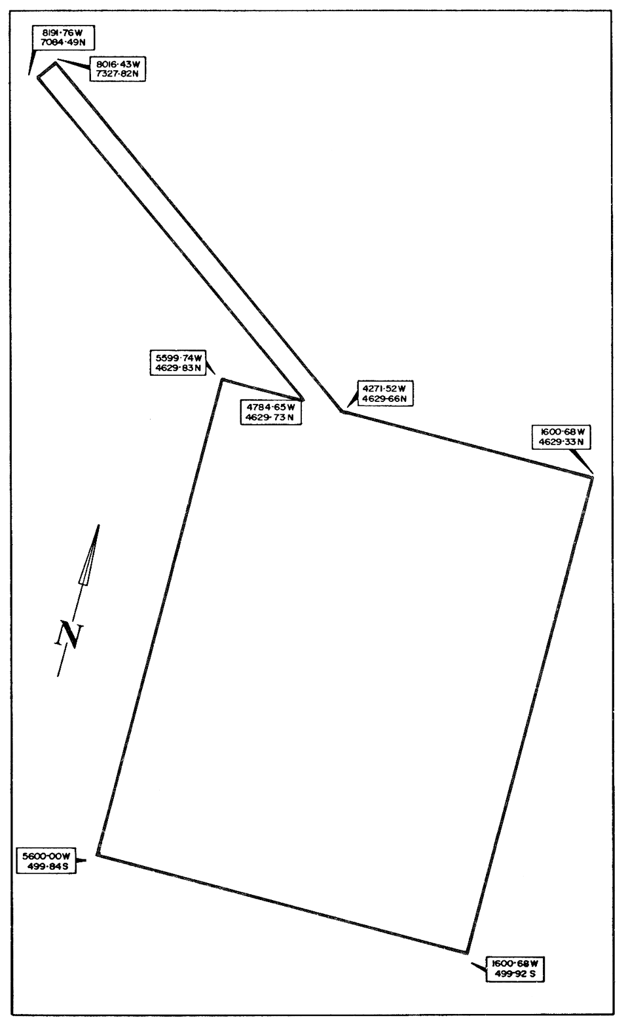
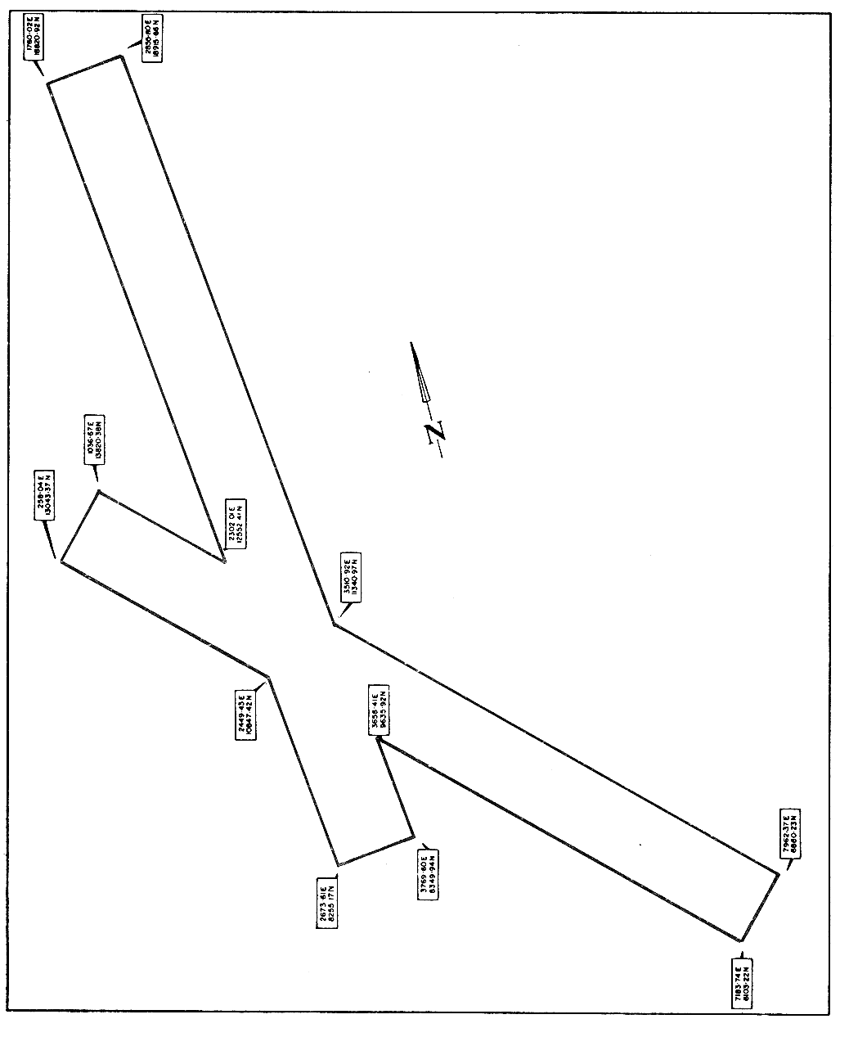
APPENDIX "B"
SOUTH AUSTRALIA—PETROLEUM ACT, 1940-1971
PETROLEUM PRODUCTION LICENCE NUMBER
I, HUGH RICHARD HUDSON, Minister of Mines and Energy in the State of South Australia pursuant to the Petroleum Act, 1940-1971 and the Cooper Basin (Ratification) Act, 1975 and all other enabling powers HEREBY GRANT jointly to SANTOS LIMITED of 183 Melbourne Street, North Adelaide DELHI INTERNATIONAL OIL CORPORATION of 33 King William Street, Adelaide VAMGAS NO LIABILITY of 151 Flinders Street, Melbourne and (Block Owners) of a Petroleum Production Licence in respect of the area described hereunder:—
DESCRIPTION OF AREA
TERMS AND CONDITIONS
1. The term of this licence is thirty one years commencing on and inclusive of the First day of January 1975 with the right, subject to carrying out adequately the obligations of the licence, to renewal from time to time on the same terms and conditions for further terms of twenty one years.
2. The licensees hereby covenant with the Minister that they will make payment of the yearly rent provided under the Petroleum Act, 1940-1971 and of the royalty referred to in the Cooper Basin (Ratification) Act, 1975 and will subject to the provisions of the Cooper Basin (Ratification) Act, 1975 comply with the provisions of the Petroleum Act, 1940-1971 and amendments thereto and with all Regulations for the time being in force under that Act and with any directions given by the Minister the Director of Mines or any other person pursuant to that Act or the said Regulations.
3. The Minister hereby gives and records his consent to the grant by the Licensees of a Sub-Licence pursuant to the provisions of the Cooper Basin (Ratification) Act, 1975 in the form of or to the effect set out in the Schedule hereto.
Signed, Sealed and Delivered by the said Minister of Mines and Energy at ADELAIDE this day of 1975.
Signed, Sealed and Delivered by the said Licensees at ADELAIDE this day of 1975.
THE SCHEDULE HEREINBEFORE REFERRED TO
THIS DEED OF SUB-LICENCE made the day of 1976
BETWEEN:
SANTOS LIMITED whose registered office is situated at 183 Melbourne Street, North Adelaide in the State of South Australia (hereinafter sometimes called "Santos" which expression where the context requires or permits shall include its successors and assigns)
AND
DELHI INTERNATIONAL OIL CORPORATION whose principal office in Australia is situated at 33 King William Street, Adelaide aforesaid (hereinafter sometimes called "Delhi" which expression where the context requires or permits shall include its successors and assigns)
AND
VAMGAS NO LIABILITY whose registered office is situated at 20 Bridge Street, Sydney in the State of New South Wales (hereinafter sometimes called "Vamgas" which expression where the context requires or permits shall include its successors and assigns)
AND
(Block Owners)
(the said companies being hereinafter collectively called "the Licensors" which expression where the context requires or permits shall include their respective successors and assigns)
OF THE ONE PART
AND
(the parties from time to time to the Unit Agreement)
(the said companies being hereinafter collectively called "the Licensees" which expression shall include their respective successors and assigns)
OF THE OTHER PART
WHEREAS:
A. The Licensors are the joint holders of Petroleum Production Licence No. granted by the Minister of Mines and Energy for the State of South Australia pursuant to the powers in the Petroleum Act, 1940-1971 and the Cooper Basin (Ratification) Act, 1975 over certain land in the State of South Australia as more particularly described in the said Petroleum Production Licence No.
B. The Licensees have entered into an agreement made as of the 1st day of January, 1975 known as the South Australian Cooper Basin Unit Agreement (hereinafter and as the same may be amended from time to time referred to as "the Unit Agreement") relating inter alia to the development and production of petroleum from that sub-surface portion of the area comprised in the said Petroleum Production Licence No. as the same is more particularly described in the Schedule hereto.
C. The Licensors with the consent of the Minister of Mines and Energy of the State of South Australia have agreed to grant and the Licensees have agreed to accept a sub-licence to exercise the rights specified in Clause 1 hereof upon the conditions specified in Clauses 2, 3, 4 and 5 hereof.
NOW THIS DEED WITNESSETH AS FOLLOWS:
1. The Licensors with the consent of the Minister of Mines and Energy of the State of South Australia hereby grant to each of the Licensees severally the exclusive right for a period of thirty-one (31) years commencing and inclusive of the first day of January, 1975 (with the right of renewal hereinafter contained) subject to the provisions of this Deed of Sub-Licence to:
(a) conduct operations for the appraisal and production of petroleum from such sub-surface portion of the area comprised in the said Petroleum Production Licence No. as is more particularly described in the Schedule hereto (hereinafter referred to as "The Unitized Zone") and subject to Clause 2 hereof to own all petroleum extracted or released therefrom; and
(b) construct and maintain upon the land comprised in the said Petroleum Production Licence No. all such facilities as the Licensors are entitled to construct and maintain thereon pursuant to Section 33 of the Petroleum Act, 1940-1971 or the Cooper Basin (Ratification) Act, 1975 (or both) of the State of South Australia and as are necessary from time to time for the full enjoyment of the rights granted pursuant to Clause 1(a) hereof.
2. Each of the Licensees hereby expressly acknowledges covenants and agrees with the Licensors and with each of the other Licensees that in the exercise of exclusive rights granted pursuant to Clause 1 hereof each Licensee shall at all times act subject to and in accordance with the provisions of the Unit Agreement (and in particular to the provisions of Clause 13.01 thereof which refers to an overriding royalty in favour of Santos) and that such rights shall entitle each Licensee to extract or release from the Unitized Zone so much of the petroleum within the Unitized Zone as such Licensee is entitled to from time to time in accordance with its Gas Unit Participation, Ethane Unit Participation, Propane Unit Participation, Butane Unit Participation, Pentanes Plus Unit Participation and its Additional Plant Products Unit Participation or Participations in accordance with the provisions of the Unit Agreement.
3. The Licensees hereby jointly and severally covenant with the Licensors that they will make payment in accordance with the Unit Agreement of the royalty referred to in the Cooper Basin (Ratification) Act, 1975 in respect to the production referred to in Clause 2 hereof and subject to the provisions of the Cooper Basin (Ratification) Act, 1975 make payment in accordance with the Unit Agreement of the yearly rent provided under the said Petroleum Act, 1940-1971 and will subject as aforesaid comply with the provisions of the said Petroleum Act, 1940-1971 and amendments thereto and with all Regulations for the time being in force under that Act and with any directions given by the Minister, the Director of Mines or any other person pursuant to that Act or the said Regulations and the Licensees hereby further jointly and severally covenant with the Licensors not to do any act or thing or make any omission which would cause the Licensors to be in breach or default of the provisions of the said Petroleum Production Licence No. or of the provisions of the said Petroleum Act, 1940-1971 and amendments thereto or of any Regulation for the time being in force under that Act or with any direction given by the Minister, the Director of Mines or any other person pursuant to that Act or the said Regulations.
4. Subject to the due compliance by the Licensees with their obligations under this Deed of Sub-Licence the Licensors hereby covenant with the Licensees:
(a) to perform the covenants and obligations on the part of the Licensors contained in the said Petroleum Production Licence No. ;
(b) that for such period as the same is required for the purpose of the Unit Agreement to exercise their rights of renewal pertaining to the said Petroleum Production Licence No. ; and
(c) to renew the provisions of this Deed of Sub-Licence on the same terms and conditions during any renewed term of the said Petroleum Production Licence No. for such period as aforesaid.
5. The rights of the Licensees or of any of them granted pursuant to the foregoing provisions of this Deed of Sub-Licence shall not be sold assigned transferred leased sub-let mortgaged pledged charged encumbered or otherwise disposed of other than subject to and in accordance with the provisions of Article XV of the Unit Agreement and subject to Section 42 of the said Petroleum Act, 1940-1971 and clause 14.2 of the Indenture annexed to the Cooper Basin (Ratification) Act, 1975.

The Schedule
(Description of Unitized Zones)
APPENDIX "C"

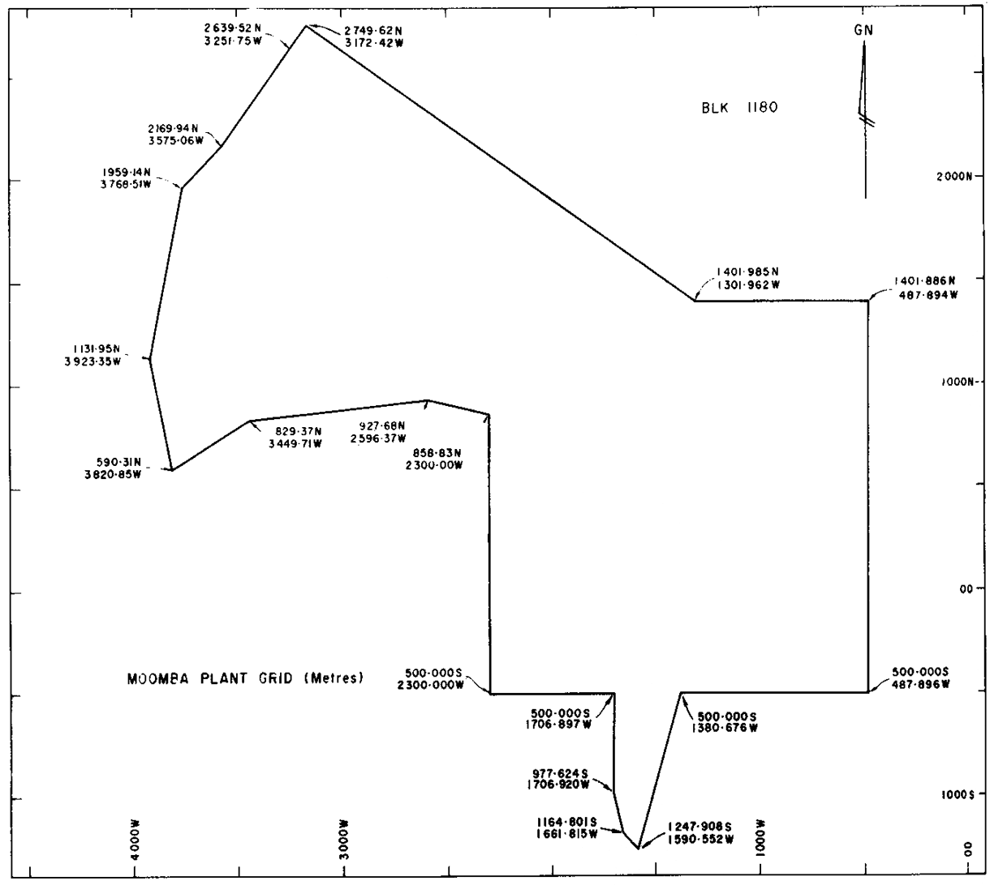

APPENDIX "D"

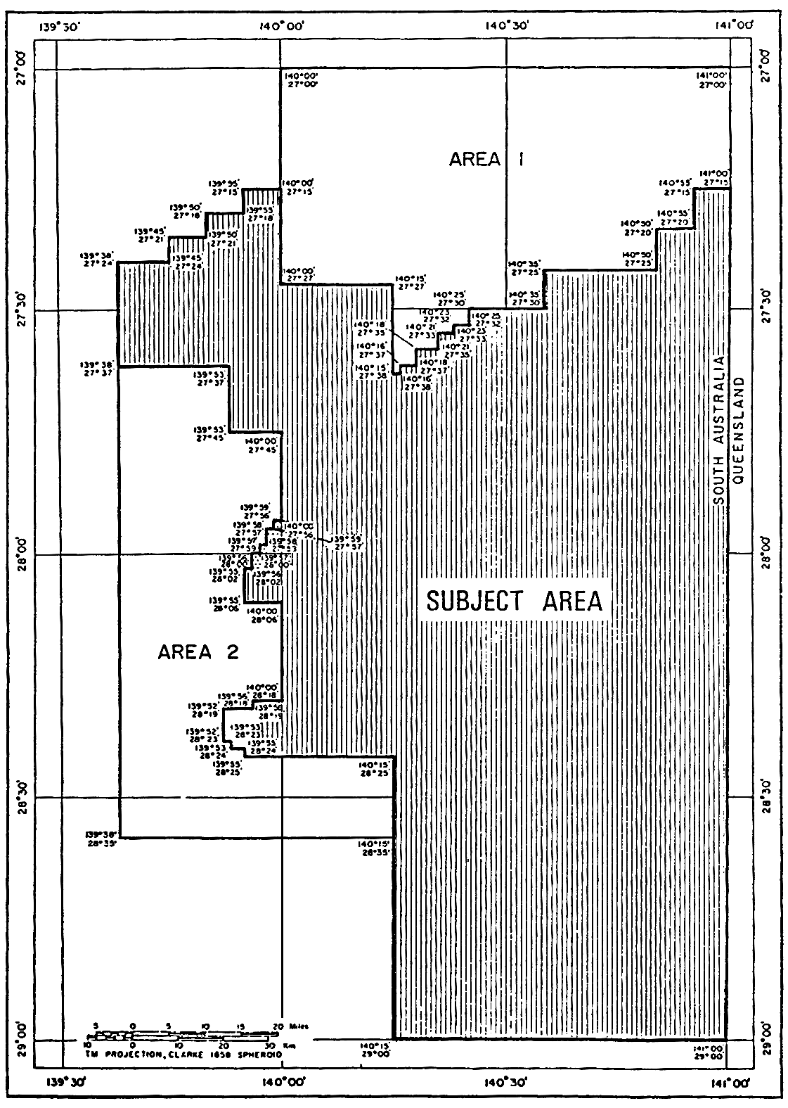
IN WITNESS WHEREOF the Parties hereto sign seal and deliver the foregoing presents and have hereunto set their respective hands and seals as of the day and year first above written.

SIGNED SEALED AND DELIVERED by THE HONOURABLE DONALD ALLAN DUNSTAN, Premier of the State of South Australia for and on behalf of the said State and in the presence of:  D.H. TAYLOR | } | D.A. DUNSTAN
THE COMMON SEAL of THE MINISTER OF MINES AND ENERGY was hereunto affixed by the authority of the Minister and in the presence of:  D.H. TAYLOR | } | H.R. HUDSON, Minister of Mines and Energy
THE COMMON SEAL of SANTOS LIMITED was hereunto affixed with the authority of a resolution of the Board of Directors and in the presence of:  D. PARTINGTON | } | JOHN BONYTHON, Director
Attest: DELHI INTERNATIONAL OIL CORPORATION M.J. McINNES, Assistant Secretary |  | BOB R. BLAIR,Vice-President
THE COMMON SEAL of ALLIANCE PETROLEUM AUSTRALIA N.L. was hereunto affixed with the authority of the Directors in the presence of:  JOHN W. CORNELIUS, Secretary | } | JOHN S. ROBINSON, Director
THE COMMON SEAL of BASIN OIL N.L. was hereunto affixed with the authority of a resolution of its Board of Directors and in the presence of:  R.C. NICHOLLS, Secretary | } | PETER LANE, Director D.M. TULLOCH, Director
THE COMMON SEAL of BRIDGE OIL N.L. was hereunto affixed with the authority of a resolution of its Board of Directors and in the presence of:  J.P. BOYER, Secretary | } | ROBERT RYKO, Director
THE COMMON SEAL of PURSUIT OIL N.L. was hereunto affixed with the authority of a resolution of its Board of Directors and in the presence of:  E.H.C. GARLAND, Secretary | } | G.O. MORRIS, Director
THE COMMON SEAL of REEF OIL N.L. was hereunto affixed with the authority of a resolution of its Board of Directors and in the presence of:  R.C. NICHOLLS, Secretary | } | PETER LANE, Director  D.M. TULLOCH, Director
THE COMMON SEAL of VAMGAS N.L. was hereunto affixed with the authority of a resolution of the Board of Directors and in the presence of:  L.L. YOUREN, Secretary | } | J.G. DONALDSON, Director
Legislative history
Notes
• Please note—References in the legislation to other legislation or instruments or to titles of bodies or offices are not automatically updated as part of the program for the revision and publication of legislation and therefore may be obsolete.
• Earlier versions of this Act (historical versions) are listed at the end of the legislative history.
• For further information relating to the Act and subordinate legislation made under the Act see the Index of South Australian Statutes or www.legislation.sa.gov.au.
Principal Act and amendments
New entries appear in bold.
Year | No | Title | Assent | Commencement
1975 | 93 | Cooper Basin (Ratification) Act 1975 | 20.11.1975 | 11.12.1975 (Gazette 11.12.1975 p3137)
1981 | 89 | Stony Point (Liquids Project) Ratification Act 1981 | 17.12.1981 | 17.12.1981
1991 | 15 | Cooper Basin (Ratification) (Royalty) Amendment Act 1991 | 11.4.1991 | 1.1.1991: s 2
2003 | 43 | Cooper Basin (Ratification) Amendment Act 2003 | 23.10.2003 | 15.12.2003 (Gazette 4.12.2003 p4374) except s 7(1) and (5)—1.7.2000: s 2(2)
Provisions amended since 3 February 1976
New entries appear in bold.
Entries that relate to provisions that have been deleted appear in italics.
Provision | How varied | Commencement
s 2 | omitted under Legislation Revision and Publication Act 2002 | 15.12.2003
s 3
s 3(1) | substituted by 43/2003 s 4 | 15.12.2003
s 9
s 9(1) | s 9 redesignated as s 9(1) by 43/2003 s 5 | 15.12.2003
s 9(2) | inserted by 43/2003 s 5 | 15.12.2003
s 10
s 10(1) | substituted by 15/1991 s 3 | 1.1.1991
s 16 | substituted by 43/2003 s 6 | 15.12.2003
s 18 | amended by 89/1981 s 4(2) | 17.12.1981
Sch
Indenture
cl 1
cl 1(1A)—(1C) | inserted by 43/2003 s 7(1) | 1.7.2000
cl 1(7) | amended by 89/1981 s 4(1), Pt XXX, Sch 5 | 17.12.1981
cl 1(10) | substituted by 43/2003 s 7(2) | 15.12.2003
cl 1(15) | inserted by 89/1981 s 4(1), Pt XXX, Sch 5 | 17.12.1981
cl 1(16) | inserted by 43/2003 s 7(3) | 15.12.2003
cl 4
cl 4(1) and (2) | amended by 89/1981 s 4(1), Pt XXX, Sch 5 | 17.12.1981
cl 6
cl 6(1) | amended by 89/1981 s 4(1), Pt XXX, Sch 5 | 17.12.1981
cl 6(1A) | inserted by 43/2003 s 7(4) | 15.12.2003
cl 6(4) | amended by 89/1981 s 4(1), Pt XXX, Sch 5 | 17.12.1981
cl 6(5) | amended by 15/1991 s 4(1) Sch | 1.1.1991
cl 6(7) | amended by 89/1981 s 4(1), Pt XXX, Sch 5 | 17.12.1981
cl 6(10) | inserted by 89/1981 s 4(1), Pt XXX, Sch 5 | 17.12.1981
cl 7
cl 7(2) | amended by 89/1981 s 4(1), Pt XXX, Sch 5 | 17.12.1981
cl 10 | substituted by 43/2003 s 7(5) | 1.7.2000
cl 11 | amended by 89/1981 s 4(1), Pt XXX, Sch 5 | 17.12.1981
cl 12 | amended by 89/1981 s 4(1), Pt XXX, Sch 5 | 17.12.1981
 | substituted by 15/1991 s 4(1) Sch | 1.1.1991
cl 12(5) | amended by 43/2003 s 7(6) | 15.12.2003
cl 14
cl 14(2) | amended by 89/1981 s 4(1), Pt XXX, Sch 5 | 17.12.1981
cl 20 | amended by 89/1981 s 4(1), Pt XXX, Sch 5 | 17.12.1981
Appendices "C" and "D" | inserted by 89/1981 s 4(1), Pt XXX, Sch 5 | 17.12.1981
Historical versions
Reprint No 1—1.7.1991

